Lab 5：MATLAB Programming

Authors | Name：何衍宁 Student ID:12311512  Name：夏天 Student ID:12311610
Objective
Lab5
In Lab5, we aim to gain a practical understanding of the Discrete-Time Fourier Transform (DTFT) by implementing its analysis and synthesis equations numerically. Specifically, we will use the FFT (Fast Fourier Transform) and IFFT (Inverse Fast Fourier Transform) functions to compute the DTFT and its inverse. We will also address two key limitations of numerical DTFT implementations: the finite length of the signal x[n] and the sampling of the continuous frequency variable ω. Through various exercises, we will learn to apply the DTFT to real-world signal processing problems, such as analyzing the tones transmitted by touch-tone phones and investigating the frequency response of discrete-time linear time-invariant (LTI) systems. We will explore all-pass systems, design LTI systems using the DTFT, and identify system characteristics. Additionally, we will study the use of partial fraction expansions for computing frequency responses and derive analytic expressions for impulse responses.
Lab results & Analysis
1.
1.Generate a speech-shaped noise (SSN), and plot the spectra of the speech signal and SSN (e.g., use Matlab function ‘psd’ or ‘pwelch’, or other power spectral density estimation functions).
The problem requires the generation of the noise spectrum from the existing speech signal, and the spectrum spectrum of the source speech signal, frequency response and speech spectrum noise.
Analysis:
The C_01_01(1).wav. Source on the pilot BB, using the existing sound source generation idiom filter. Then construct a section of white noise, and get spectral noise after filtering the white noise.
clc;
clear;
[x,fs] = audioread('C_01_02.wav');
x = x';
t = linspace(0,length(x)/fs,length(x));

figure;
plot(t,x);
xlabel('x'),
ylabel('y(t)'),
grid on;
legend('y with no rawing');

figure;
y10 = repmat(x,1,10);
nfft = 512;
noverlap = nfft/2;
window = hamming(nfft);
[P,w]=pwelch(y10,window,noverlap,nfft,fs);
b = fir2(3000,w/(fs/2),sqrt(P/max(P)));
[H,W] = freqz(b,1);
plot(W,abs(H));
xlabel('w'),
ylabel('H(jw)'),
grid on;
legend('H(jw)');

figure;
N = length(x);
noise = 1-2*rand(1,N);
SSN = filter(b,1,noise);
plot(t,SSN);
xlabel('t'),
ylabel('SSN(t)'),
grid on;
legend('SSN(t)');
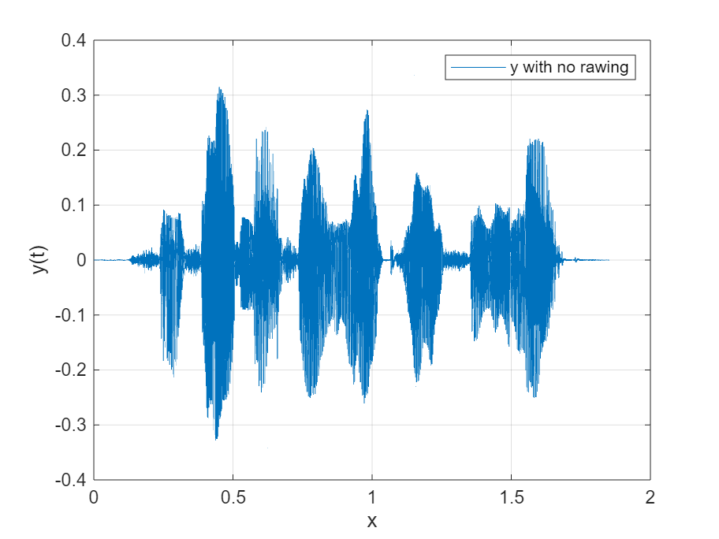
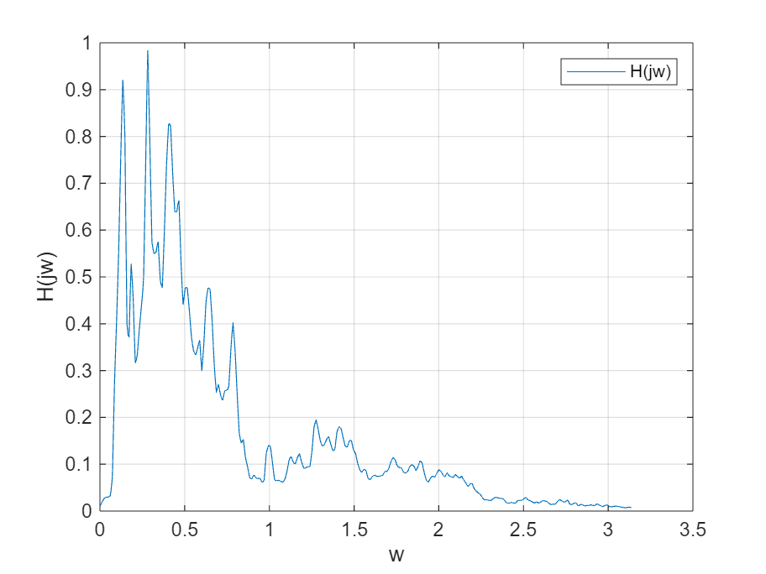
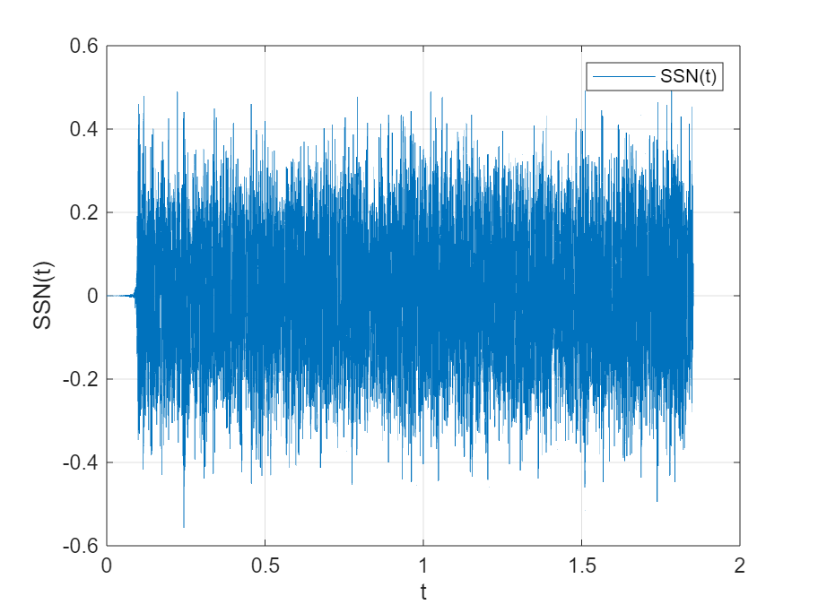
Lab result:
The image of the original sound signal, the frequency response of the filter, and the resulting spectral noise are shown in the figure.

2.
The problem requires that under the SNR of -5 dB, speech spectral noise is added to the original speech signal to generate a noisy signal, and then the energy of the noisy signal y relative to x(t) of the original speech signal is standardized.
Analysis:
SNR = -5 = 20*lg(norm(x)/norm(SSN)),norm(SSN)=norm(x)*10^(1/4).

Thus, the energy of spectral noise is adjusted to verify the signal-to-noise ratio. The adjusted spectrum noise is added to the original signal to generate a signal with noise, and then the noise is adjusted
The signal energy is the same as the original signal。
clc;
clear;
[x,fs] = audioread('C_01_02.wav');
x = x';
t = linspace(0,length(x)/fs,length(x));

y10 = repmat(x,1,10);
nfft = 512;
noverlap = nfft/2;
window = hamming(nfft);
[P,w]=pwelch(y10,window,noverlap,nfft,fs);
b = fir2(3000,w/(fs/2),sqrt(P/max(P)));
[H,W] = freqz(b,1);

N = length(x);
noise = 1-2*rand(1,N);
SSN = filter(b,1,noise);

figure;
SSNf = SSN/norm(SSN)*norm(x)*(10^0.25);
SNR = 20*log10(norm(x)/norm(SSNf));
y0 = x+SSNf;
y = y0/norm(y0)*norm(x);
plot(t,y);
xlabel('t'),
ylabel('y(t)'),
grid on;
legend("y(t)");
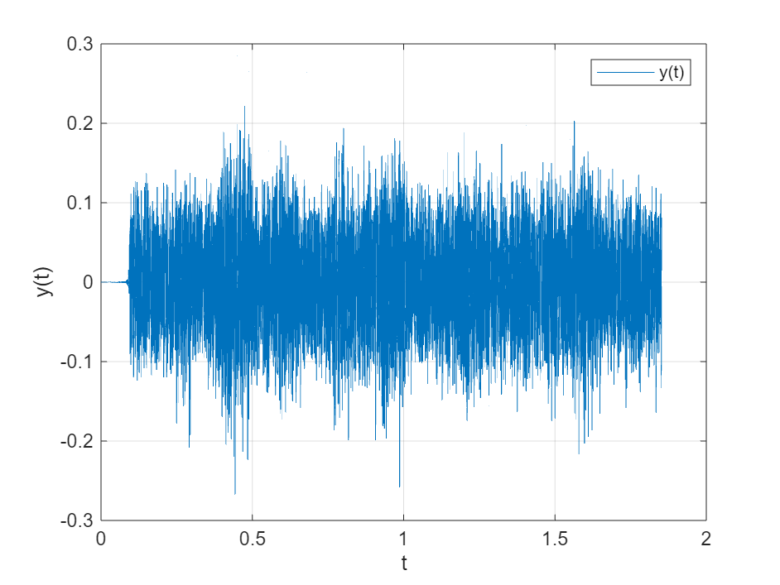

Lab result:
The resulting noisy sound is shown in the figure.

3.
The envelopments are obtained with second-order 100Hz,200Hz,300Hz and sixth-order 200Hz Butterworth low-pass filters, and the differences are compared. The envelope of the original signal is used here.
3. Extract speech envelope
1) with 2nd-order low-pass filter and cutoff frequency fcut= 100, 200, and 300 Hz. Plot these three envelope waveforms in one plot, and describe the difference among them.
2) with 2nd and 6th-order low-pass filter and cutoff frequency 200 Hz. Plot these two envelope waveforms in one plot, and describe the difference between them.
Analysis:
The Butterworth filter is constructed according to the order and cut-off frequency shown in the question
tclc;
clear;
[x,fs] = audioread('C_01_02.wav');
x = x';
t = linspace(0,length(x)/fs,length(x));

y10 = repmat(x,1,10);
nfft = 512;
noverlap = nfft/2;
window = hamming(nfft);
[P,w]=pwelch(y10,window,noverlap,nfft,fs);
b = fir2(3000,w/(fs/2),sqrt(P/max(P)));
[H,W] = freqz(b,1);

N = length(x);
noise = 1-2*rand(1,N);
SSN = filter(b,1,noise);

SSNf = SSN/norm(SSN)*norm(x)*(10^0.25);
SNR = 20*log10(norm(x)/norm(SSNf));
y0 = x+SSNf;
y = y0/norm(y0)*norm(x);

figure
[b1,a1] = butter(2,100/(0.5*fs));
[b2,a2] = butter(2,200/(0.5*fs));
[b3,a3] = butter(2,300/(0.5*fs));
[b4,a4] = butter(6,200/(0.5*fs));
yb1 = filter(b1,a1,abs(x));
yb2 = filter(b2,a2,abs(x));
yb3 = filter(b3,a3,abs(x));
yb4 = filter(b4,a4,abs(x));
subplot(3,1,1)
plot(t,yb1),
xlabel('t'),
ylabel("Envelop Wave"),
grid on,
legend("Order=2,f=100hz");
subplot(3,1,2)
plot(t,yb2),
xlabel('t'),
ylabel("Envelop Wave"),
grid on,
legend("Order=2,f=200hz");
subplot(3,1,3)
plot(t,yb3),
xlabel('t'),
ylabel("Envelop Wave"),
grid on,
legend("Order=2,f=300hz");

figure
subplot(2,1,1)
plot(t,yb1),
xlabel('t'),
ylabel("Envelop Wave"),
grid on,
legend("Order=2,f=200hz");
subplot(2,1,2)
plot(t,yb1),
xlabel('t'),
ylabel("Envelop Wave"),
grid on,
legend("Order=6,f=200hz");
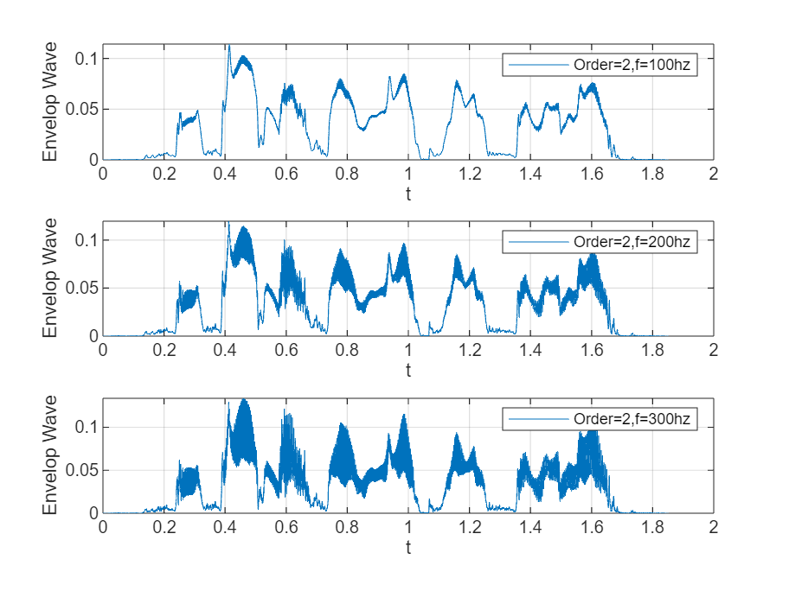
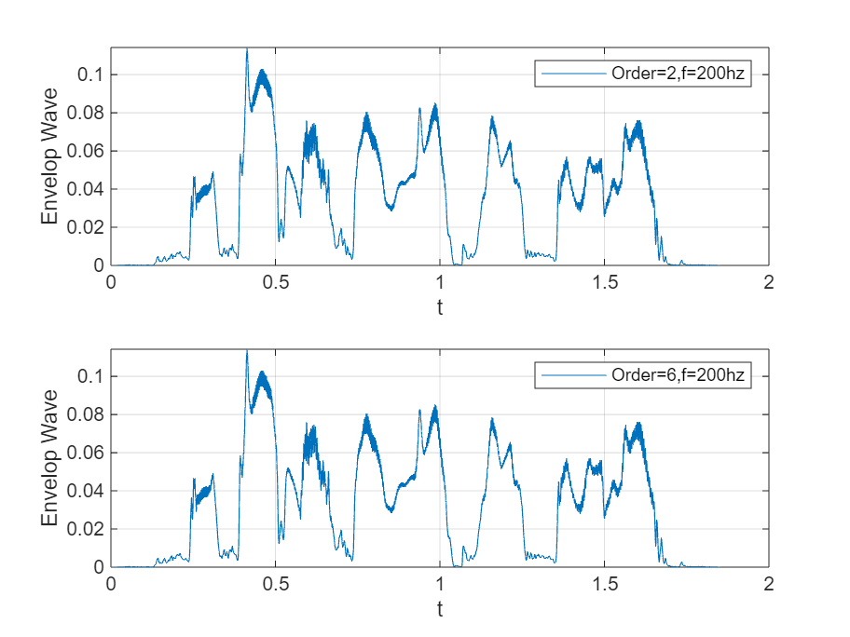
Lab result:
From the picture,
1、 The order is the same, the cut-off frequency is different, and the filter with a higher cut-off frequency can retain the high-frequency signal and reduce distortion.
2、 When the cutoff frequency is the same and the order is different, the filter with higher order has better filtering effect. The acquisition envelope is more complete, and fewer high-frequency signals are missed.

4.
4. One *.wav files for lab 5 and the coming lab project 1: ‘C_01_02.wav’

Analysis:
Record an audio signal and save it as a.wav file
clc;
clear;
[x,fs] = audioread('C_01_02.wav');
x = x';
t = linspace(0,length(x)/fs,length(x));

y10 = repmat(x,1,10);
nfft = 512;
noverlap = nfft/2;
window = hamming(nfft);
[P,w]=pwelch(y10,window,noverlap,nfft,fs);
b = fir2(3000,w/(fs/2),sqrt(P/max(P)));
[H,W] = freqz(b,1);

N = length(x);
noise = 1-2*rand(1,N);
SSN = filter(b,1,noise);

SSNf = SSN/norm(SSN)*norm(x)*(10^0.25);
SNR = 20*log10(norm(x)/norm(SSNf));
y0 = x+SSNf;
y = y0/norm(y0)*norm(x);

audiowrite('new_signal.wav',y0,fs);
Lab result:
The audio saved after processing has a noticeable noise, but the original content can still be heard.
Note: Please indicate meaning of the symbols in all expressions. Please indicate the coordinate and unit in all figures.
Experience
- We initially struggle to grasp why the DTFT cannot be computed exactly in a numerical setting due to the finite length of the signal x[n]x[n] and the limited number of frequency samples ω. This limitation can lead to errors or approximations in our analysis. To overcome this, we focus on understanding how the FFT and IFFT functions approximate the continuous DTFT by using finite data and discrete frequency samples.
- We find it tricky to understand how all-pass systems work, especially when the frequency response magnitude is equal to one for all frequencies. It could be challenging to relate this concept to practical signal processing. Exercise 5.3 will help us understand all-pass systems by providing examples and explaining their behavior in the context of the DTFT. We will take a closer look at how the frequency response characteristics impact the system's behavior, which will make this concept more digestible.
- Designing and identifying LTI systems through the DTFT can be complex, particularly when translating between the frequency and time domains. We may also face difficulty in understanding how to use the DTFT to extract meaningful system properties. Exercises 5.4 and 5.5 will guide us through the process of both designing and identifying LTI systems. We will apply the DTFT to specific problems, which will help us build a practical understanding of how the DTFT can be used to solve real-world system design and analysis problems.
Score | 100/100

字体：英文Times new Roman；

